V-Electronics: Revolutionizing Smart Device Management

**Phase 2: Org Setup & Configuration**

After completing the problem analysis in Phase 1, the next logical step in the **V-Electronics Salesforce Project** was to prepare the Salesforce environment. This phase focused on configuring the organization (org) so that it matched the business requirements identified earlier. It ensured that the technical foundation was strong, secure, and scalable, allowing users to work efficiently from the beginning of the implementation.

**1. Introduction**

The Salesforce platform provides flexibility through its configuration options, enabling businesses to customize environments to their operational and security needs. In this phase, key administrative tasks were performed such as setting up company details, defining user access, establishing role hierarchies, and creating secure login policies.

The goal was to ensure that V-Electronics had a well-structured, policy-compliant Salesforce org that reflected its organizational hierarchy and workflows.

**2. Objectives of this Phase**

* To configure Salesforce settings according to the company’s operational requirements.
* To establish user roles, profiles, and permissions that support secure collaboration.
* To implement Organization-Wide Defaults (OWD) and Sharing Rules for proper data visibility.
* To set up sandboxes and prepare deployment strategies for controlled development.
* To enforce secure login and access management policies.

**3. Detailed Description of Contents**

**Salesforce Editions**

Evaluated available editions (Enterprise, Developer, Professional) and chose the **Developer Edition** for building and testing. This ensured access to core functionalities without licensing limitations in the learning phase.

**Company Profile Setup**

* Defined company information such as name, default locale, fiscal year, and currency.
* Ensured regional settings (time zone and language) matched the business context of V-Electronics.
* This setup allowed accurate reporting and seamless communication across teams..
* Created a Salesforce Developer Org using <https://developer.salesforce.com/signup>.
* Verified the account, set the password, and gained access to the Salesforce Setup page.

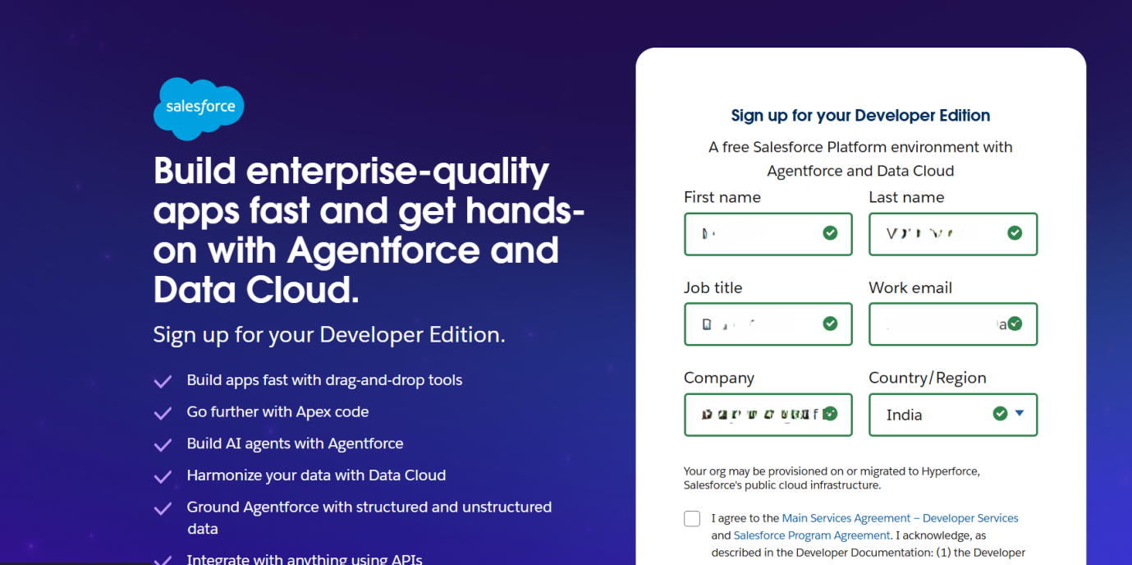

**Business Hours & Holidays**

* Configured official business hours (e.g., 9 AM to 6 PM, Monday–Saturday).
* Added organization-wide holidays to align SLA calculations and escalation rules.
* These settings ensured workflows such as case escalations respected working hours.

**Fiscal Year Settings**

* Configured fiscal year to align with the financial cycle of V-Electronics (April–March).
* This ensured that reports and dashboards reflected accurate revenue tracking.

**User Setup & Licenses**

* Created different types of users (Sales Agents, Managers, Admins).
* Assigned licenses according to roles, ensuring the right level of Salesforce features.
* Example: Sales Agents → Salesforce Platform License, Managers → Salesforce Sales Cloud License.

**Profiles**

* Defined baseline permissions for users such as object-level access, field-level security, and app visibility.
* Example: Sales Agent profile allowed creation of Leads and Orders but restricted access to system setup.

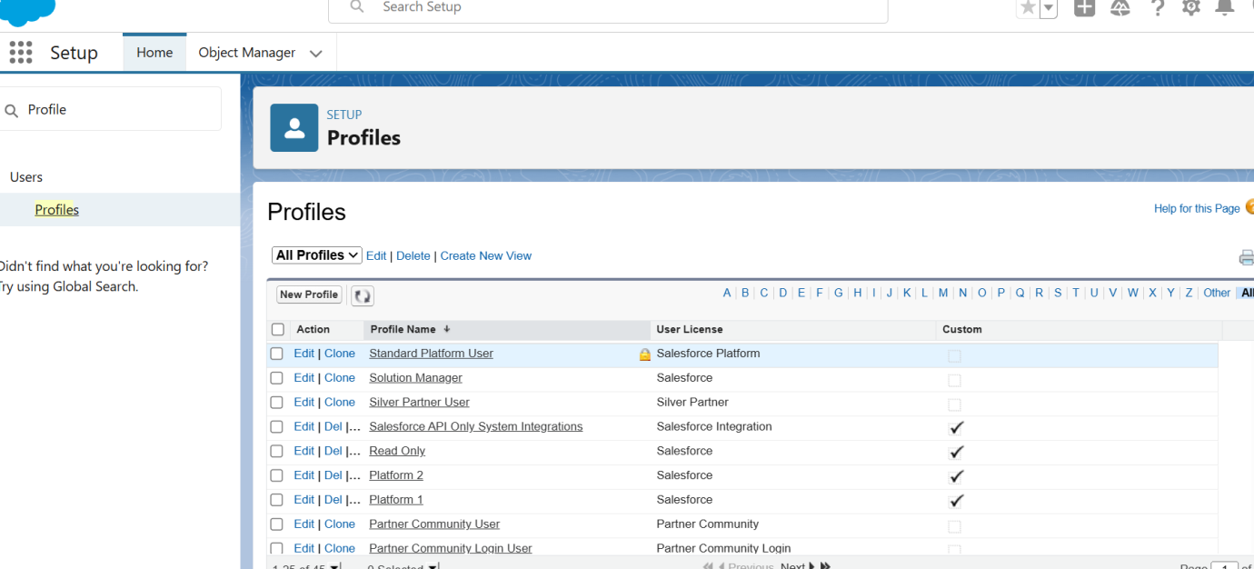

**Roles**

* Created a role hierarchy to reflect the reporting structure:
  + Sales Agent → Sales Manager → Regional Head → Director.
* Roles ensured data rolled up appropriately for managerial oversight.

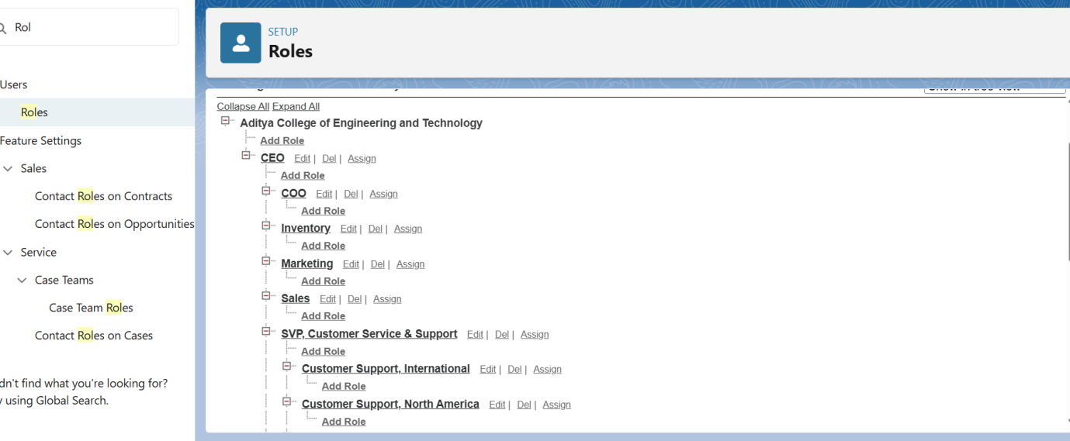

**Permission Sets**

* Implemented additional access beyond profiles without changing the baseline security.
* Example: Certain Sales Agents were given a “Discount Approval” permission set for handling special requests.

**OWD (Organization-Wide Defaults)**

* Defined baseline record access across the org.
* Example:
  + Leads: Private (agents only see their own leads).
  + Products: Public Read-Only (agents can view but not edit products).
  + Orders: Controlled by parent (visibility based on related customer record).

**Sharing Rules**

* Extended data visibility for collaboration.
* Example: Orders were shared with the Finance role for payment processing.

**Login Access Policies**

* Defined login IP ranges to restrict unauthorized access.
* Implemented session timeouts to enhance data security.
* Allowed admins to log in as users for troubleshooting.

**Dev Org Setup**

* Created **Developer Org** for building and testing customizations.
* Used this as the central playground for initial configurations.

**Sandbox Usage**

* Created **Full Sandbox** for UAT (User Acceptance Testing).
* Created **Developer Sandbox** for isolated development and testing.
* This ensured smooth deployments without affecting production data.

**Deployment Basics**

* Introduced migration techniques: Change Sets, ANT Migration Tool, and SFDX CLI.
* Defined a **release strategy** (Dev → QA → UAT → Production).
* This structured approach reduced deployment risks.

**4. Deliverables/Outcomes of Phase 2**

* Configured Salesforce Company Profile.
* Defined business hours, holidays, and fiscal year.
* Created user roles, profiles, and permission sets.
* Set OWD and Sharing Rules for secure data visibility.
* Established login and access policies.
* Created and documented Sandbox environments.
* Prepared a deployment strategy.

**5. Conclusion**

Phase 2 successfully set up the **Salesforce foundation** for V-Electronics. By configuring user roles, security settings, and org policies, the system was tailored to reflect real-world operations. This secure and scalable environment became the backbone for all subsequent phases, especially **Phase 3 (Data Modeling & Relationships)**, where the business entities would be designed and structured.